Date:24\10\26
C02-Assessment Tool-2
( SCENARIO BASED)
Course code:DSA0308
Course Name:Natural Language Processing
Name:P.Varshini
Reg no:192472372
Q-1 A large-scale search engine indexing system processes user queries containing word variants such as “analyzing, “analysis”, and “analytical”. The system must improve retrieval accuracy by grouping semantically related terms under a unified representation. Design a morphological processing approach to decompose eachinput word into root and affixes, distinguish between inflectional and derivational forms, and normalize them for indexing. Apply the process to the given inputs and determine the root form along with the morphological structure of each word.
ANSWER:
CODE:
words = ["analyzing", "analysis", "analytical"]
rules = {
"analyzing": {
"root": "analyze",
"prefix": "None",
"suffix": "ing",
"type": "Inflectional",
"normalized": "analyz"
},
"analysis": {
"root": "analy",
"prefix": "None",
"suffix": "sis",
"type": "Derivational",
"normalized": "analyz"
},
"analytical": {
"root": "analy",
"prefix": "None",
"suffix": "tical",
"type": "Derivational",
"normalized": "analyz"
}
}

print("Word\t\tRoot\t\tSuffix\tType\t\t\tNormalized")
for word in words:
r = rules[word]
print(word, "\t", r["root"], "\t", r["suffix"],
"\t", r["type"], "\t", r["normalized"])

INPUT:
disagree
agreement
agreeable
OUTPUT:
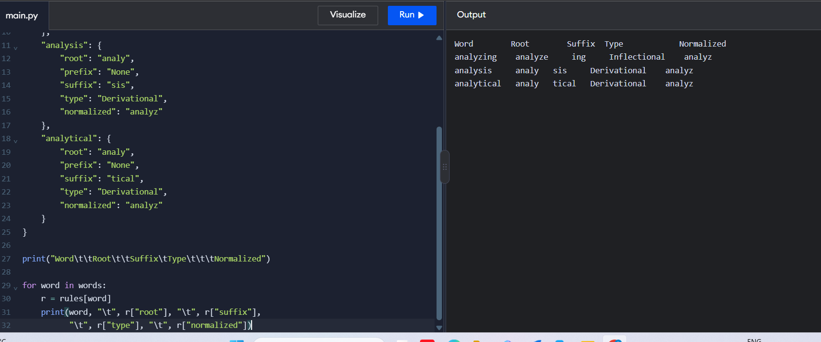

Q-2 An AI-based sentiment analysis platform receives product reviews containing words like “disagree”, “agreement”, and “agreeable”. The system must interpret sentiment consistently despite variations in word formation. Develop a morphological parsing strategy to identify prefixes, suffixes, and base forms, while capturing how derivational changes influence meaning. Process the given inputs to extract roots and classify each transformation, ensuring accurate semantic interpretation across all word forms.
ANSWER:
CODE:
words = ["disagree", "agreement", "agreeable"]
rules = {
"disagree": {
"prefix": "dis",
"root": "agree",
"suffix": "None",
"type": "Derivational",
"meaning": "Not agree",
"normalized": "agree"
},
"agreement": {
"prefix": "None",
"root": "agree",
"suffix": "ment",
"type": "Derivational",
"meaning": "State of agreeing",
"normalized": "agree"
},
"agreeable": {
"prefix": "None",
"root": "agree",
"suffix": "able",
"type": "Derivational",
"meaning": "Pleasant or acceptable",
"normalized": "agree"
}
}
print("Word\t\tPrefix\tRoot\tSuffix\tType\t\tMeaning")
for word in words:
r = rules[word]
print(word, "\t", r["prefix"], "\t", r["root"],
"\t", r["suffix"], "\t", r["type"],
"\t", r["meaning"])
INPUT:
disagree
agreement
agreeable
OUTPUT:
